Rural CTE Strategy Facilitation Guide

While there are many ways to engage stakeholders and partnerships around your rural CTE strategy, to help you make the most of the CTE on the Frontier: Rural CTE Strategy Guide, we have developed a companion facilitation guide. You may use this as is or modify it to meet your state’s needs.

Roles
- Facilitator: The facilitator drives the agenda forward and manages the overall discussion. Any person within the policy team may serve in this role, though it is most effective when filled by a person who is comfortable talking with and pushing the conversation forward with everyone on the team, no matter their position. Importantly, the facilitator drives the discussion forward, but without necessarily participating, in order to preserve impartiality.
- Recorder: The recorder takes notes on the discussions had, with particular focus on any next steps or final decisions. This person can be the same as the facilitator or a separate team member. The recorder may also serve as a participant during the discussion, but he or she must ensure that notes are accurate and fully represent all sides of any discussions. Participants in the discussion will know they have been heard if the recorder has written down their contributions, so this role is crucial for affirming participation.
- Policy team members: The policy team members are those who participate in the conversation and have the ability to drive the appropriate changes once any policy gaps have been identified. The policy team may be a group of staff within one CTE agency, but ideally will also include representatives from both secondary and postsecondary agencies along with representatives from other state and local agencies or boards related to economic and workforce development. You may also want to include some local perspectives.

Materials Needed
- Print-outs or digital copies of the Rural CTE Strategy Guide for each participant
- Printed copies of any relevant state policies for each participant, such as CTE pathway approval/review policies, federal state plans (for Perkins, Every Student Succeeds Act and even the Workforce Innovation & Opportunity Act), relevant grant programs, broadband/technology policies or audits, etc.
- Printed copies or access to any relevant labor market and student access/participation data
- Printed copies of the Group Instructions
- Flip chart for the recorder to take notes
- Markers and pens for taking notes

Pre-Work

Participants should review existing state policies and related documents as well as the Rural CTE Strategy Guide. It is important that participants have a firm understanding of the current state policy environment. This includes any data on student access and outcomes in rural areas, as well as state or regional labor market data.

Group Instructions
Today we will be discussing a series of questions designed for state leaders to use as they reflect on current efforts to expand access to high-quality CTE and career-focused pathways and experiences in rural communities and to identify future opportunities and actions.

This discussion will not end with a ready and simple solution to our state’s challenges in rural areas; rather it will end with more insight on which strategies to investigate further and which activities to prioritize implementing.

In order for this conversation to be successful in its goals, it is imperative that we all be open and honest with our ideas and opinions, as well as respectful of others’ ideas and opinions.

As we work through these questions, it’s critical to keep in mind that tackling this challenge will take a comprehensive, multi-faceted and cross-sector strategy. While activities and programs can make a difference, true reform at scale can only happen with intentionality and cohesion.

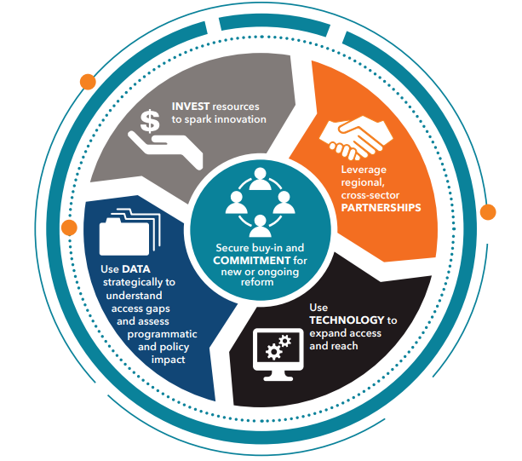

Sample Facilitation Plan
Time (In Minutes) | Activity | Facilitation Notes
00:00-00:10 | Introduction  - Facilitator introduces self and walks through the agenda for the day.  - Participants introduce themselves to the group and take no more than 30 seconds each to answer the icebreaker question: What is the biggest challenge our state faces when it comes to providing high-quality CTE in rural areas? | - Depending on how familiar participants are with each other, this may also be a great time to take a few extra minutes and discuss norms for participation, such as:  - No technology use not related to the discussion, meaning no email or texts;  - No interruptions; and  - The recorder will capture all ideas and opinions.
00:10-00:35 | Full Group Discussion: First Strategy  - Facilitator leads a discussion on the first strategy in the Rural CTE Strategy Guide: Securing buy-in and commitment for the reform at the state and local levels:  - Facilitator reads introduction paragraph for this strategy out loud.  - Facilitator poses questions to the full group from the “Reflect” section first, adding follow up questions as necessary based on responses.  - Facilitator poses questions from the “Look Ahead” section, adding follow up questions as necessary based on responses.  - Recorder recaps this discussion, making sure to call out any next steps identified. Recorder asks for the group to determine specific owners and deadlines for next steps. | - If participants have not reviewed the Rural CTE Strategy Guide ahead of time, add five minutes to this section to allow them to look over the questions they will be discussing.  - While each of the discussion questions are useful questions to ask the group, if you do not get to each one, do not be concerned. It is up to the facilitator to assess if the conversation needs to move forward to the next question, or if the conversation on the current question is so valuable that more time should be given to it.  - It’s up to the facilitator if all of the questions are discussed or if the group should focus on a subset of questions.  - Push the group to identify actionable next steps as they discuss the strategy. For example, a next step of “examine and improve student transportation policies” is not specific enough or timebound, and therefore easy to not follow through on. Ask the group – Who will examine the policies? By when? What steps must we take to change those policies once we identify improvements?
00:35-01:10 | Small Group Discussions  - Facilitator takes five minutes to describe the exercise and divide participants into four groups.  - Each small group is assigned one of the other four strategies:  - Use data strategically to understand access gaps and assess programmatic and policy impact;  - Leverage regional, cross-sector partnerships;  - Use technology to expand access and reach; and  - Invest resources to spark innovation.  - One person from the small group reads the introduction paragraph from their strategy out loud.  - Small groups then have a discussion on the “Reflect” section of their strategies, after identifying one person to record for the small group.  - Small groups have a discussion on the “Look Ahead” section of their strategies.  - The small group recorders each take five minutes to summarize the discussions and next steps with the groups. | - Even though the participants will be in small groups leading their own discussions, there is still an active role for the facilitator. He or she should walk around the room, listen in on small group discussions, and ask probing questions where it makes sense. This can help ensure that small groups stay on task.  - If there are not enough participants to break into four groups, they can be broken into two groups and repeat the small group discussions and share out in order to cover all four remaining strategies.  - Try to vary the makeup of each small group so that each group represents a variety of departments, job titles and viewpoints.
01:10-01:40 | Share Out  - Facilitator brings all of the small groups back together for a full group share out and debrief of their conversations.  - One representative from each small group discussion takes no more than five minutes to summarize the key takeaways and next steps from their conversation.  - Facilitator asks the full group for reactions to the takeaways and next steps, and allows participants to ask clarifying questions. | - This is an area where it will be very easy to run over time if small group representatives do not keep their summaries brief. Facilitator should feel comfortable interrupting these share outs as needed to move the agenda forward.
01:40-02:00 | Next Steps and Close Out  - Recorder reads through all next steps identified, and asks the full group to assign specific owners and deadlines.  - Facilitator leads full group discussion to gather reactions and questions from the group.  - Facilitator closes the meeting by committing to sending the next steps to the group and following up on whether or not they have been completed. | - This part of the meeting is perhaps the most important, as is the follow-up from this discussion. Participants may have identified important and useful next steps, but if there isn’t one person coordinating follow-through, those next steps may easily be forgotten once participants return to their daily work routines.

